Documentation for the Timetable Segregator

This Excel based project aims to segregate the individual division timetables for all years and segregate them into the individual timetables for classes, labs and faculty all through Excel Macros.

Usage of the Program

When opening the shared Excel sheet, first ensure Macros are enabled. Before opening the Excel file, right-cl ick on the file and go to Properties. If you are on Windows 11 then select More Options and then go to Properties. At the bottom of the Properties window there should be a Security section with a checkbox that says “Unblock”. Check this box, click apply and close the window. If the checkbox is not there you can directly open the excel file.

Now having opened the excel file, there will be a main sheet with some buttons on it.

This is the sheet through which the macros will be controlled and run. It will also function as the first sheet that the macro reads.

Start copy-pasting all the timetable data into sheets for each division of each year. Creating and editing in this file itself is possible but not recommended.

Ensure that the data pasted is correct and as per the format (mentioned below in a separate section) before running the macros.

EG of the main Control sheet modify it according to your preference

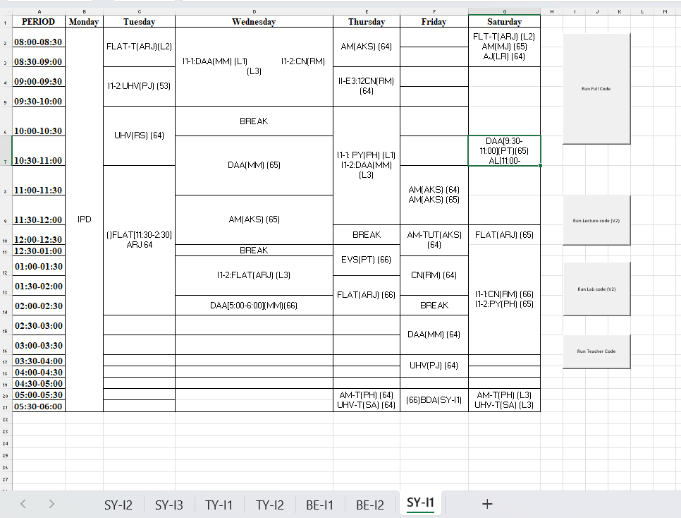

NOTE: Before running the macros, make sure there are no extra sheets. All sheets (including the one with the Run buttons) should have timetable data in them.

Now to run the macros there are 4 options:

1. Run All: Generates all the timetables for Labs, Classrooms, and Faculty Members. Asks for the names of Classrooms and Labs to be separated by spaces

Example Input for classrooms: 64 65 66 53

Example Input for Labs: L1 L2 L3 CSDS-L1

NOTE: If a Lab/Class name is not specified in the prompt, all Lectures/Labs pertaining to that Lab/Class will be ignored and will not reflect in the final timetable. This applies to typographical errors as well. If a lab is accidentally named L5 instead of L4, it will not reflect in the timetable for L4 and will appear in L5 instead.

1. Run Class: Generates the timetables for Classes only. Will ask for input like in Run All.
2. Run Labs: Generates the timetables for Labs only. Will ask for input as mentioned above.
3. Faculty Timetable: Generates Faculty timetable. Does not ask for any input. If there are any typing errors in faculty names (Eg: MN instead of MM, a new sheet will be created which considers MN as a separate faculty member)

After giving the inputs to each Run option, the macros will take time to generate all the timetables. At the end, you should have all the desired timetables generated as per the input data provided.

After running the Macros

Having run the desired Macro, crosscheck the generated timetables for any issues. If there are any issues in the macro, then check the initial data for any typographical errors. If there is a clash or overlap in the timetables, the data for both sessions will appear in the cells.

If there are any glaring issues or runtime errors, delete ALL the generated sheets and preserve the initial sheets. Check for any issues in the text and try running the macro again.

If there are any updates made to timetables, and you wish to generate the timetables for, say, only the classes again, you will still have to delete all generated sheets before running the macro, else the macro will process all the sheets and either throw an error or Excel will crash.

Format for Input Data

Sheets:

The sheet name should be the same as the class whose timetable will be pasted there. It is from this name that the Classroom and Lab timetables will display which class is currently in the session.

The sheet should have the following first rows and columns:

1. First row should have: Period in A1, followed by the days of the week.
2. First column should have: Period in A1, followed by the time of day in 30-minute slots. (8:00-8:30, 8:30-9:00 and so on)

Cell Data:

For normal lectures, the data should be as follows:

SUBJ(FAC)(CL)

Where:

SUBJ is the subject (As DBMS, SE, etc.)

FAC is the faculty member’s initial (As RP, NAF, etc.)

CL is the classroom (As 64, 65, 43, etc.)

These classroom codes are the same codes asked later when running the macro.

For Labs, the data string should be as follows:

BATCH-J:SUBJ(FAC)(LAB) BATCH-K:SUBJ(FAC)(LAB)

Where:

BATCH-J and BATCH-K is the batch of that class (As I3-2, I2-1 etc. Year does not matter here as it will be appended later from the sheet name)

LAB is the Lab code. The lab code can be any string as long as there are no spaces in the name and it does not contain any characters that make an invalid sheet name (These are: / \ ? \* [ ] )

Examples: I3-1(SE)(NA) I3-2(ARVR)(PG)

Both the batches can be separated by any number of spaces. Spaces within a certain batch session are to be avoided.

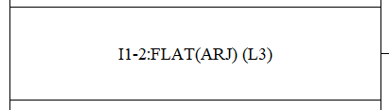

For tutorials:

The structure is more or less the same as Lectures. The only key difference is that the tutorial indicator should not be in brackets. If two teachers are in the same tutorials they are to be mentioned differently eg  
 FLAT(T)(MM,NK) (65) IS Wrong

FLAT(T)(MM)(65) FLAT(T)(NK)(65) is Right

WRONG: FLAT(T)(MM)(65)

CORRECT: FLAT-T(MM)(65) or FLAT-Tut(MM)(65)

For electives:

In the case of electives or other such lectures/labs which have 3, or in some special cases even 4 sessions happening at the same time, simply write each lecture/lab as if it was an individual lecture and separate the various lectures with spaces.

Example:

For Honours/Minors:

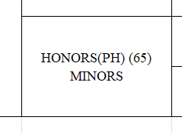

Specifying Teacher Code and Room/Lab no as in the above case “PH” , “65” will cause It to be treated like any other lecture/Lab getting resulting it in showing in the final lab lecture and Teacher timetable for the respective Lab And Teacher

Just Plain Minors Honours with no brackets will cause it to be ignored and not reflect in the main sheet

Special Cases:

In certain cases, it may so happen that there are two lectures/labs happening parallelly and are running for different durations of time. Earlier MS-Word provided the option to vertically split cells in order to make this functionality. However, such a function cannot be implemented in Excel due to various limitations. To show such lectures, they will have to be put in this format:

In the above example, I2-1 has a lab from 2pm-4pm. The time is placed in the square brackets after all the other data of faculty and lab/classroom. The other students have ARVR and IS lectures in L3 and L6, which also has its time mentioned.

This will cause the lectures or labs to be slotted in the time slots mentioned in [ startTime-EndTime ] in the respective Lab/Lecture sheets and teacher sheets

NOTE: In such a case it is important to mention the time slot for ALL sessions happening, regardless of whether it fits the slot exactly or not. Failing to provide the time in square brackets will result in a runtime error, and the program will terminate midway.

Steps to Be followed for Deploying the Frontend , Backend Files

1. Extract the Frontend , Backend Files to a directory

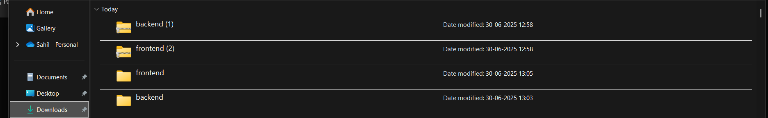

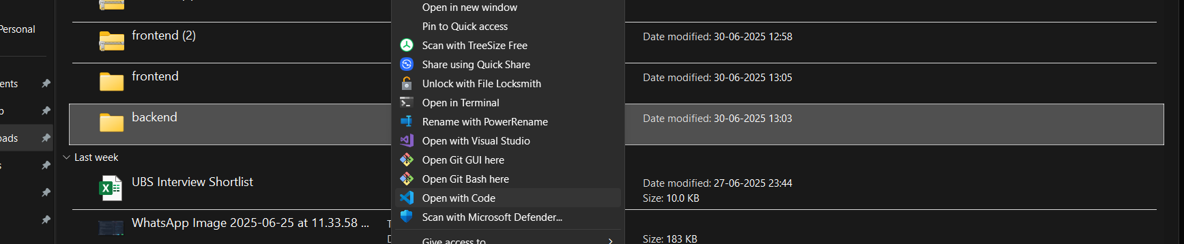 2) Open the Extracted zip files in Visual Studio Code

1. 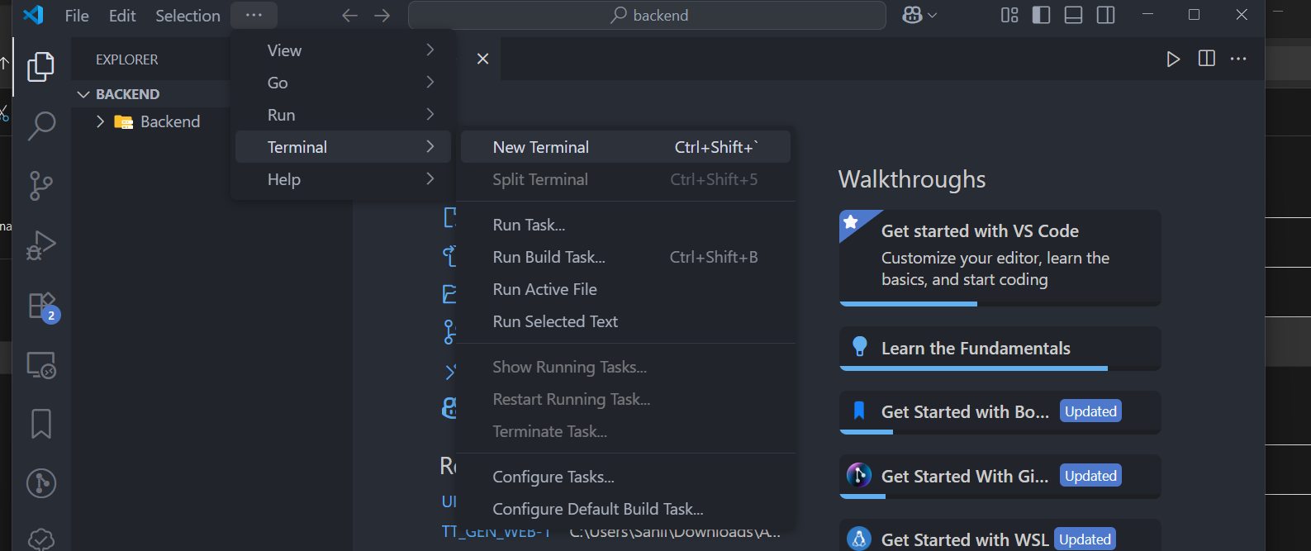Open The terminal in the Newly Opened Visual Studio Code Tabs and Run the below commands  
     
   Opening the terminal
2. A) FOR THE BACKEND FOLDER IN VISUAL STUDIO AFTER OPENING TERMINAL

* CD backend
* npm install
* npx nodemon server.js

B) FOR THE BACKEND FOLDER IN VISUAL STUDIO AFTER OPENING TERMINAL

* CD websocket
* npm install
* npm start

THE ABOVE SHOULD SUCESFULLY START THE WEBSITE AT LOCALHOST:3000  
 THE BACKEND WILL START RUNNING AT LOCALHOST 5000 OF YOUR MACHINE